Michael J. Nohilly, Mayor
John Butler, Council President
Mindy Horowitz, Councilwoman
Mervin Franks, Councilman
Michael Delia, Councilman
Michael DeSarno, Councilman

Lori Reibrich, RMC, CMR
Borough Administrator/
Borough Clerk
Borough of Interlaken
100 Grasmere Avenue
Interlaken, NJ 07712
(732) 531-7405
(732) 531-7099 fax

www.interlakenboro.com
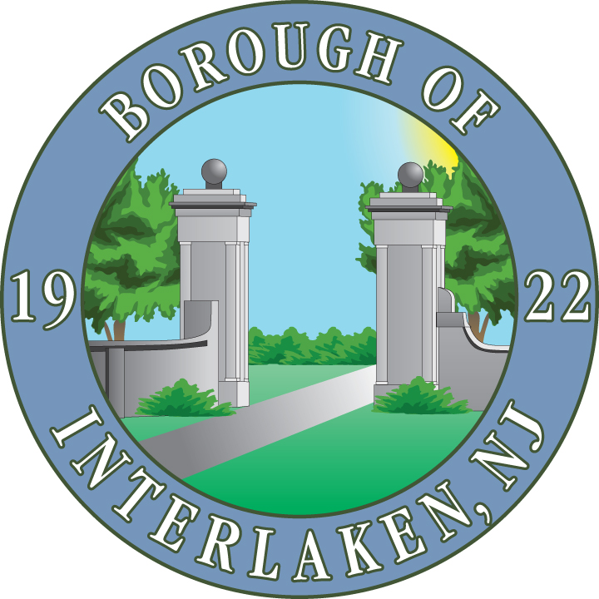

“Committed To Our Community”

NO KNOCK LIST APPLICATION
Section 4-1.7 Collection, Preparation and Maintenance of a Non-Solicitation List

The office of the Administrator/Clerk shall collect and maintain a list of addresses of those premises where the owner and/or occupant has notified the Borough Clerk that soliciting, or canvassing is not permitted on his/her/their premises. To be included on this non-solicitation list residents shall complete a form which shall be available online or at the Clerk’s office in the municipal building. The Administrator/Clerk shall submit the non-solicitation list to the Police on a yearly basis which non-solicitation list shall be distributed to applicants seeking a license to solicit or canvass pursuant to the provisions of this section. The licensee shall not solicit or canvass at any address on the non-solicitation list.

Any persons violating any provisions of this subsection shall, upon conviction, be subject to be subject to the general penalties under Chapter 1, Section 1-5.

Please return the completed form to:
By Mail/Hand Delivery/ Drop Box: By Email:

Borough of Interlaken lreibrich@interlakenboro.com
100 Grasmere Avenue
Interlaken NJ 07712

Name:

Address:

City/State/Zip:

Email:

Phone:

