Michael J. Nohilly, Mayor
John Butler, Council President
Mindy Horowitz, Councilwoman
Michael Delia, Councilman
Mervin Franks, Councilman
Michael DeSarno, Councilman
Leonard Blasucci, Councilman

Lori Reibrich, CMR
Borough Administrator/
Borough Clerk
Borough of Interlaken
100 Grasmere Avenue
Interlaken, NJ 07712
(732) 531-7405
(732) 531-7099 fax

www.interlakenboro.com
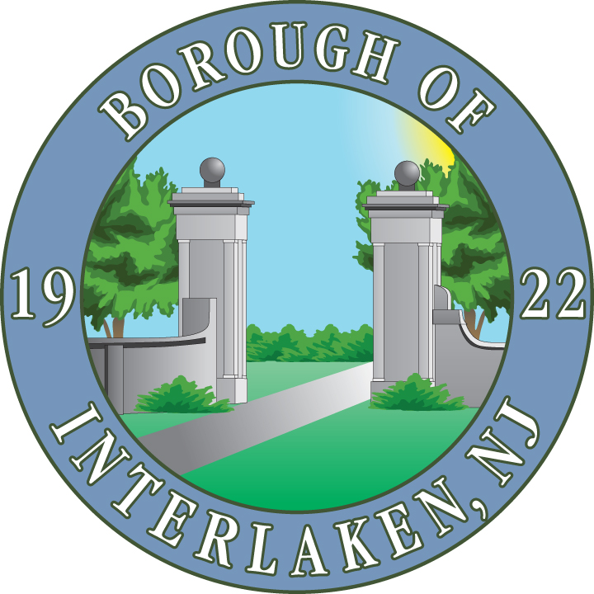

“Committed To Our Community”

Facility Use Application
(Please attach copy of driver’s license)

Name: Address:

Home Phone: Cell Phone:

Email: Driver’s License Number:

Name of Organization/Individual:

Purpose: Dates Desired:

Hours Desired: to Estimated Attendance:

REQUESTED USE: Interlaken Park (725 Bridlemere Avenue):
____ Baseball/Softball Diamond ____Picnic / Food Service
(Check all that apply) ____ Playground ____Food Service
Borough Hall (100 Grasmere Avenue):
____ Meeting Room (max 49 persons)

The undersigned representative certifies that those using the facilities agree to abide by the regulations established by the Borough of Interlaken and that all information provided is complete and correct, and that no false or misleading information, or false statements have been given.

Name: Signature: Date:

HOLD HARMLESS AGREEMENT:
“To the fullest extent permitted by law, (Name of Facility User) agrees to defend, pay on behalf of, indemnify, and hold harmless the Borough of Interlaken, its elected and appointed officials, its agents, employees and volunteers and others working on behalf of the Borough of Interlaken, against any and all claims, demands, suits or loss, including all costs connected therewith, and for any damages which may be asserted, claimed or recovered against or from the Borough of Interlaken, its elected and appointed officials, its agents, employees, volunteers or others working on behalf of the Borough of Interlaken, by reason of personal injury, including bodily injury or death and/or property damage, including the loss of use thereof, which arises out of or is in any way connected or associated with this contract.”

BY:
Facility User Date

INSURANCE REQUIREMENTS:
Authorization for the use of facilities is contingent upon the applying organization furnishing a copy of a Certificate of Insurance, naming the Borough of Interlaken as “Additional Insured”. Failure of the applicant to provide a valid certificate of insurance will render the application invalid and prohibit use of the facilities. See below for insurance requirements.

Non-Profit/Charitable Groups
- General Liability $300,000 per loss (minimum)
- Borough of Interlaken named as “additional insured”
- Hold Harmless Agreement

Commercial (for profit) Groups
- General Liability $500,000 per loss(minimum)
- Borough of Interlaken named as “additional insured”
- Hold Harmless Agreement

RESTROOM FACILITIES REQUIREMENTS:
Authorization for use of the ball field facilities for activities that are in a duration of four (4) hours or more require the organization making the request to provide restroom facilities in the form of a portable restroom. The organization making the request must provide proof of rental of portable restroom facility, along with the date confirmation from the rental company. The proof of rental should also include that the facility will be delivered prior to the start of the event and picked up the same day or the morning immediately following the event. The applicant requesting the field use accepts full responsibility for the portable restroom. For weekend events, verification of the existence of the restroom facilities associated with an approved permit will be enforced by the Deal Police Department. Failure of the applicant to provide the portable restroom will render the application invalid and prohibit use of the facilities.

FOR OFFICE USE ONLY

Permit Approved:

Permit Denied:

AUTHORIZED SIGNATURE: DATE:

cc: Deal Police Department
Department of Public Works

